Guide
Week | Descriptor | Topic
2 | Numbers, operations and relationships | - Counting forward and backwards 1-50  - Identify, recognise number symbols 1-50  - Identify, recognise and read number names.
3 | Numbers, operations and relationships | - Describe, compare and order 1-30  - Compare whole numbers up to 10 using smaller than, greater than, more than, and equal to.
4 | Numbers, operations and relationships | - Recognise and identify South African money.
5 | Numbers, operations and relationships | - Addition and subtraction
6 | Space and shape (Geometry) | - Positions (On top, behind, under etc)
7 | Space and shape (Geometry) | - Follows directions to move around the classroom.
8-9 | Space and shape (Geometry) | - 3D shapes

Number chart
1 | 2 | 3 | 4 | 5 | 6 | 7 | 8 | 9 | 10
11 | 12 | 13 | 14 | 15 | 16 | 17 | 18 | 19 | 20
21 | 22 | 23 | 24 | 25 | 26 | 27 | 28 | 29 | 30
31 | 32 | 33 | 34 | 35 | 36 | 37 | 38 | 39 | 40
41 | 42 | 43 | 44 | 45 | 46 | 47 | 48 | 49 | 50
51 | 52 | 53 | 54 | 55 | 56 | 57 | 58 | 59 | 60
61 | 62 | 63 | 64 | 65 | 66 | 67 | 68 | 69 | 70
71 | 72 | 73 | 74 | 73 | 73 | 77 | 78 | 79 | 80
81 | 82 | 83 | 84 | 85 | 86 | 87 | 88 | 89 | 90
91 | 92 | 93 | 94 | 95 | 96 | 97 | 98 | 99 | 100

Introduction
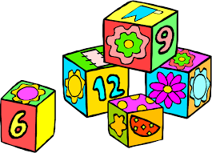

Week 2
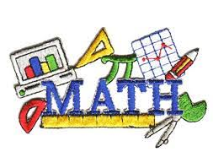

Group 1
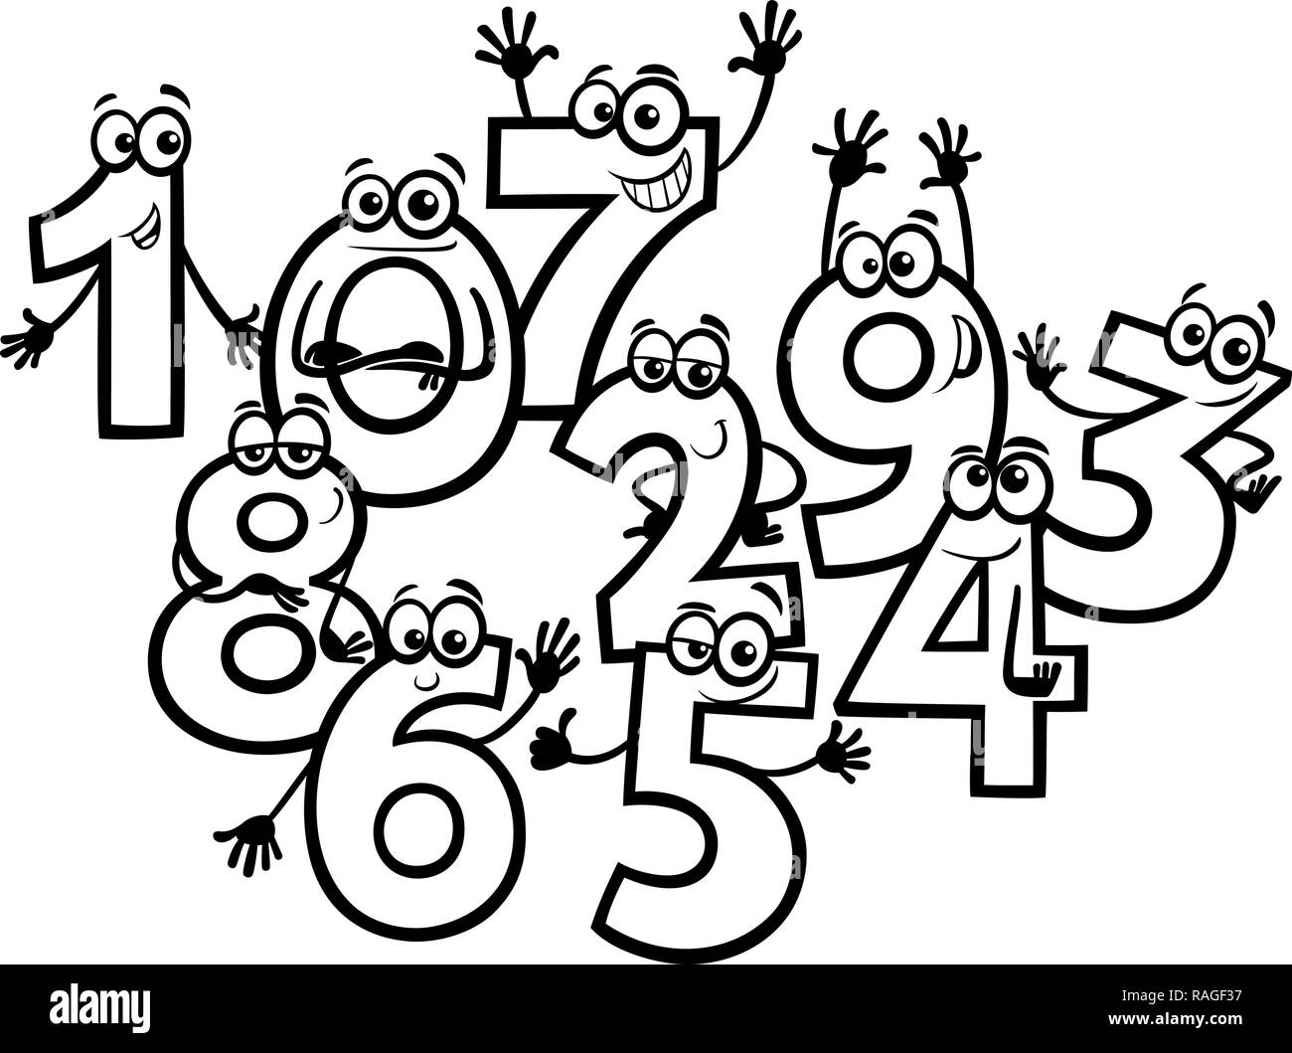

This is the number 1. There is 1 rabbit at the farm.

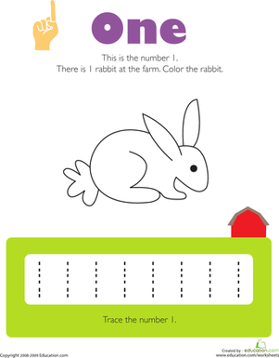

Fun with numbers
Circle the correct number
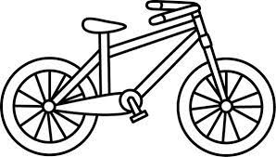

4 2 3

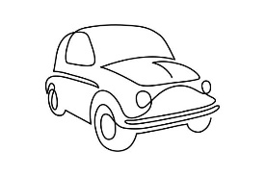
3 5 4

  4 2 1 |  | 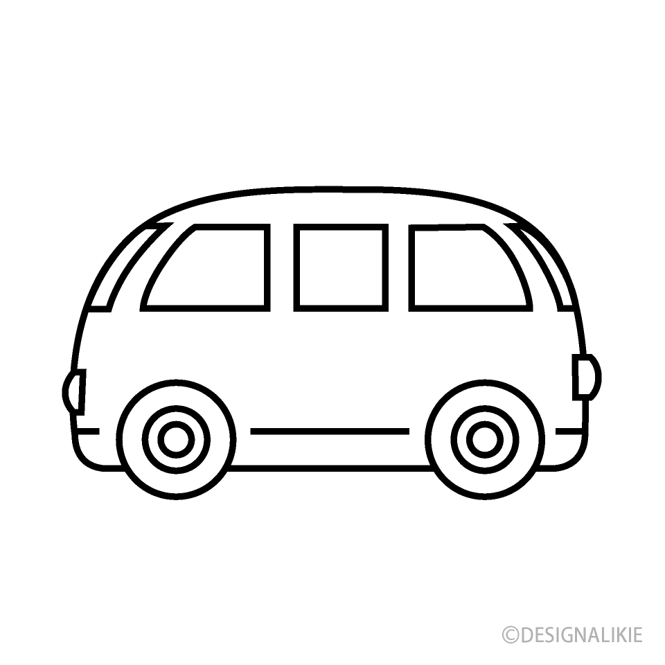  1 3 2

Match it up
Draw lines to connect the numbers and pictures that go together

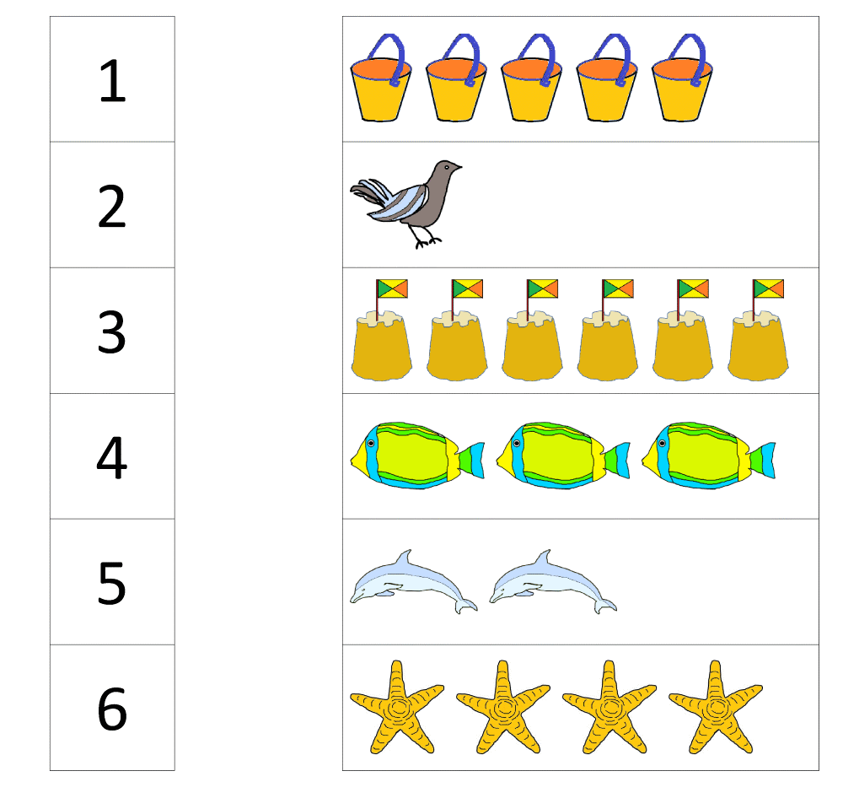

Group 2

Trace the numbers

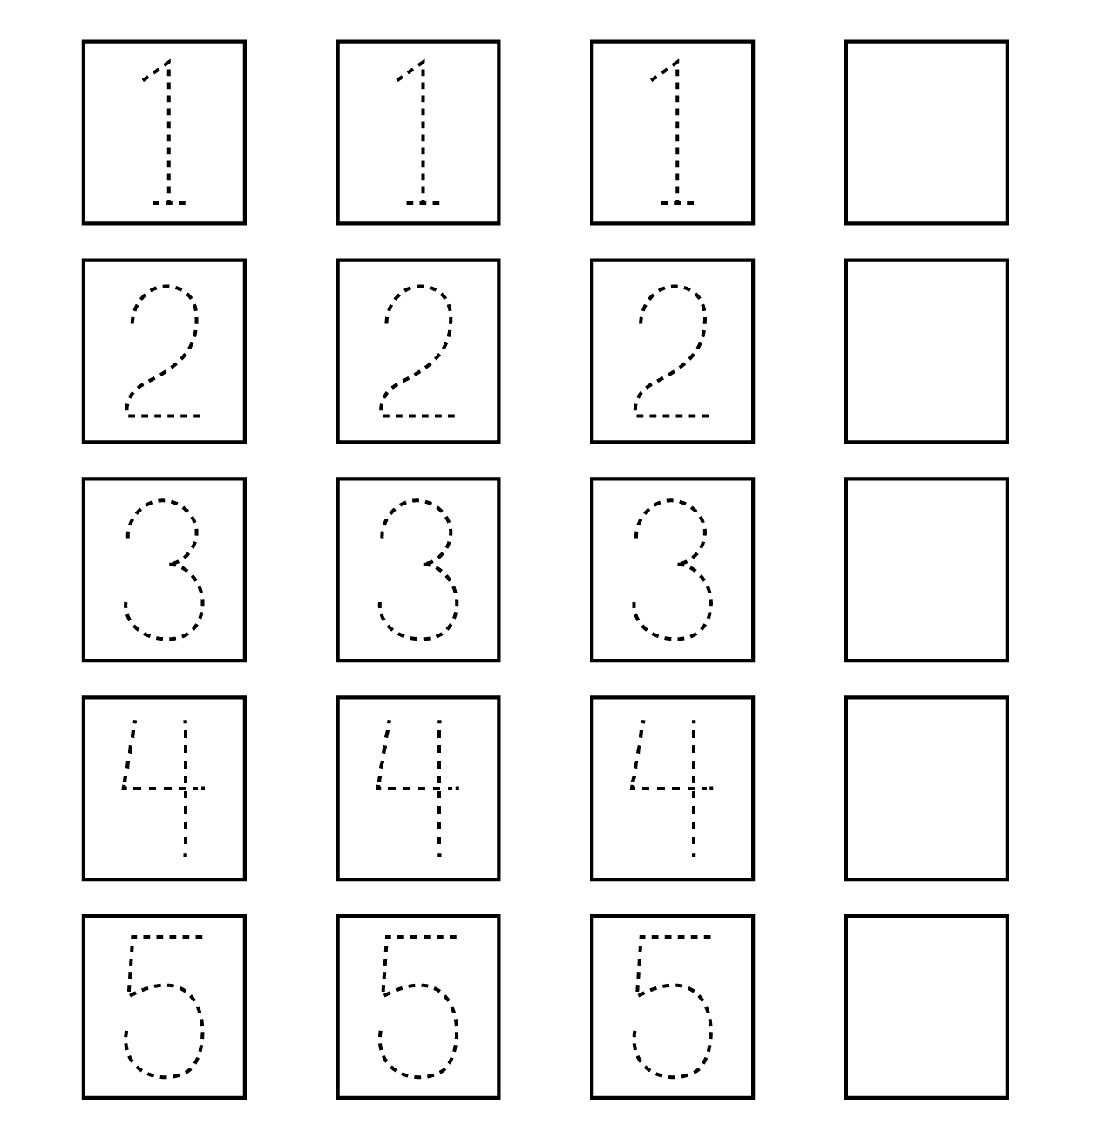

What comes next?
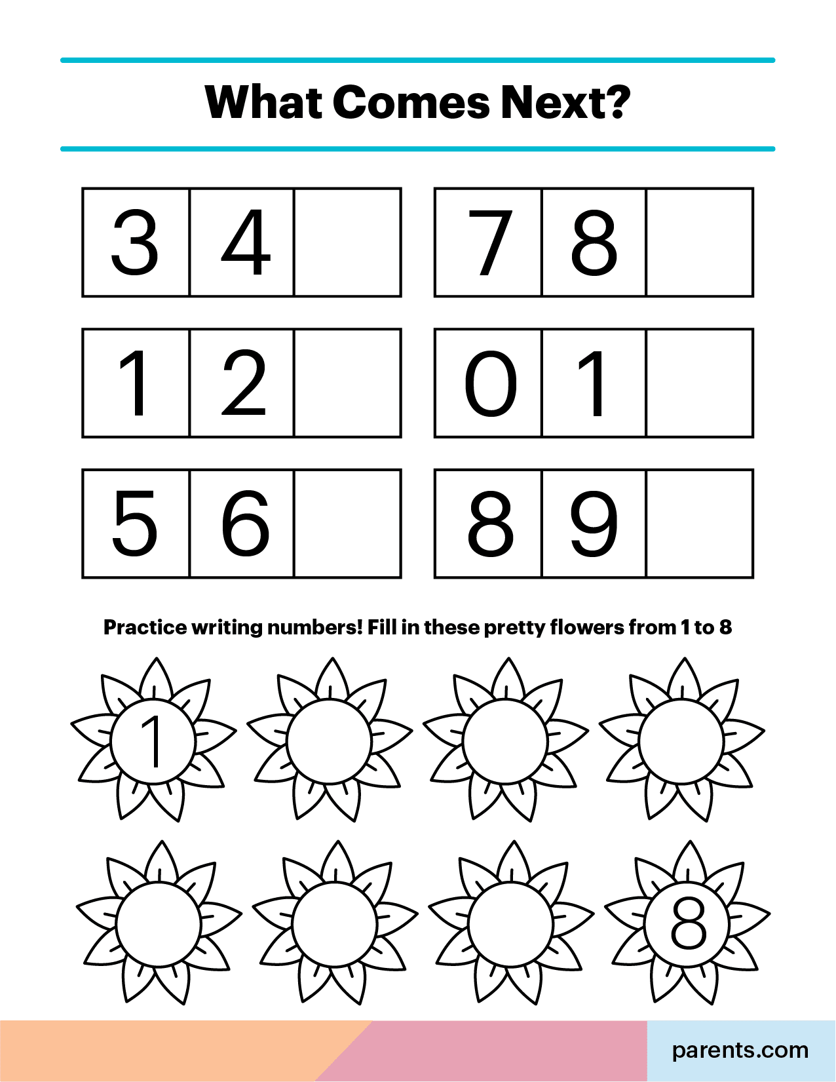

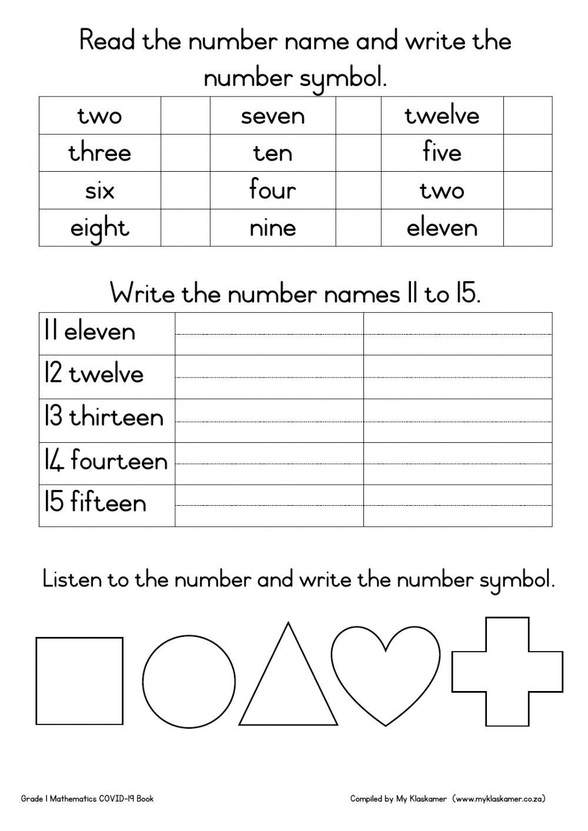
Group 3

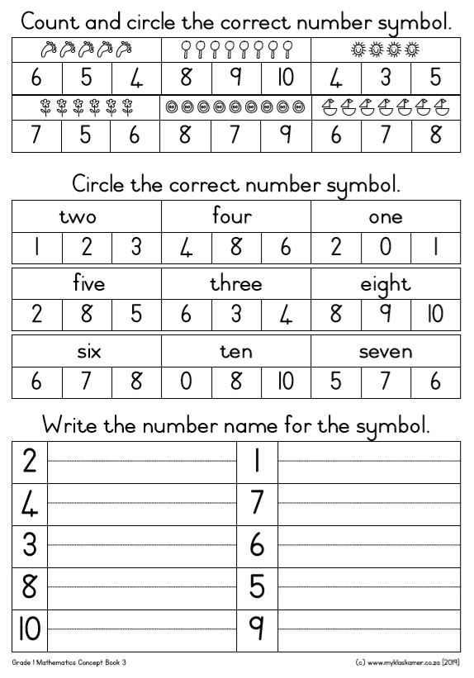
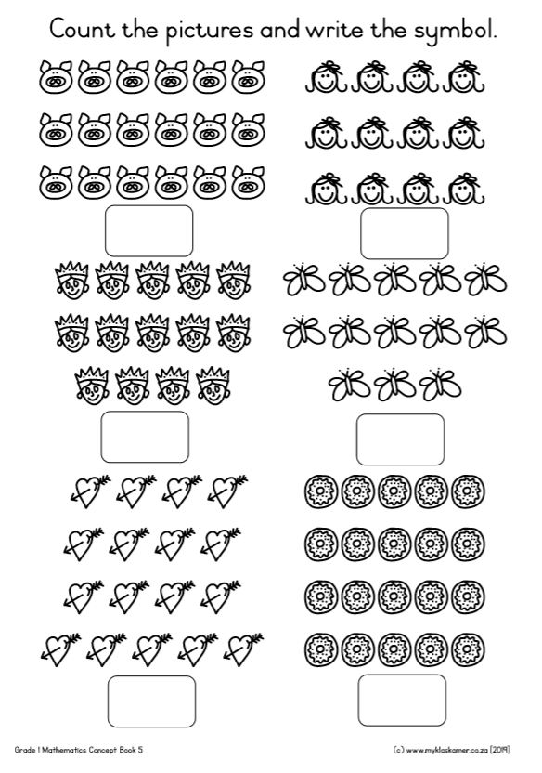

Missing letters
Fill in the missing numbers

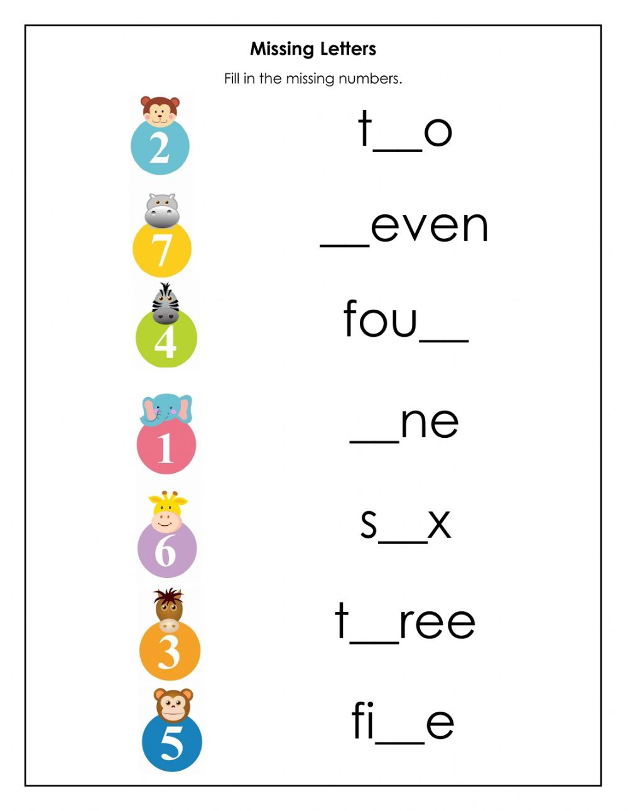
Week 3

Group 1

Trace the number 8 and colour
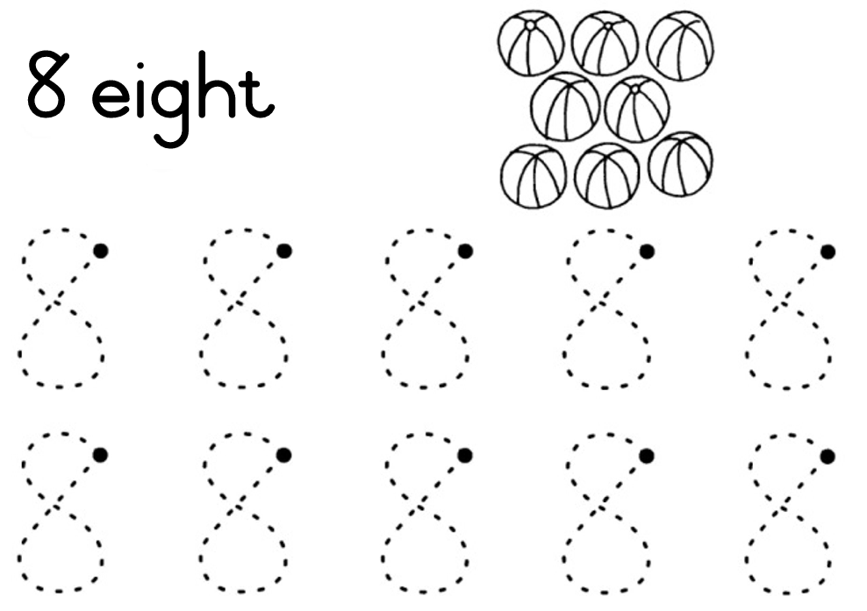

Trace the numbers

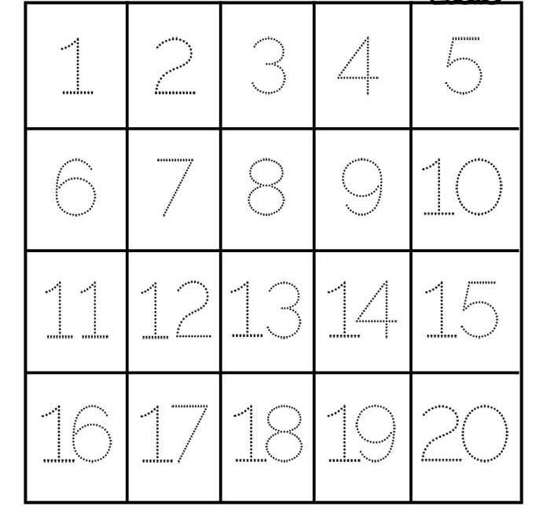

Group 2

fill in the missing numbers in order.

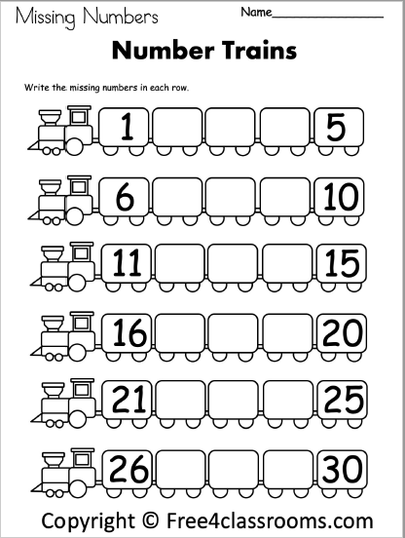

Order the numbers
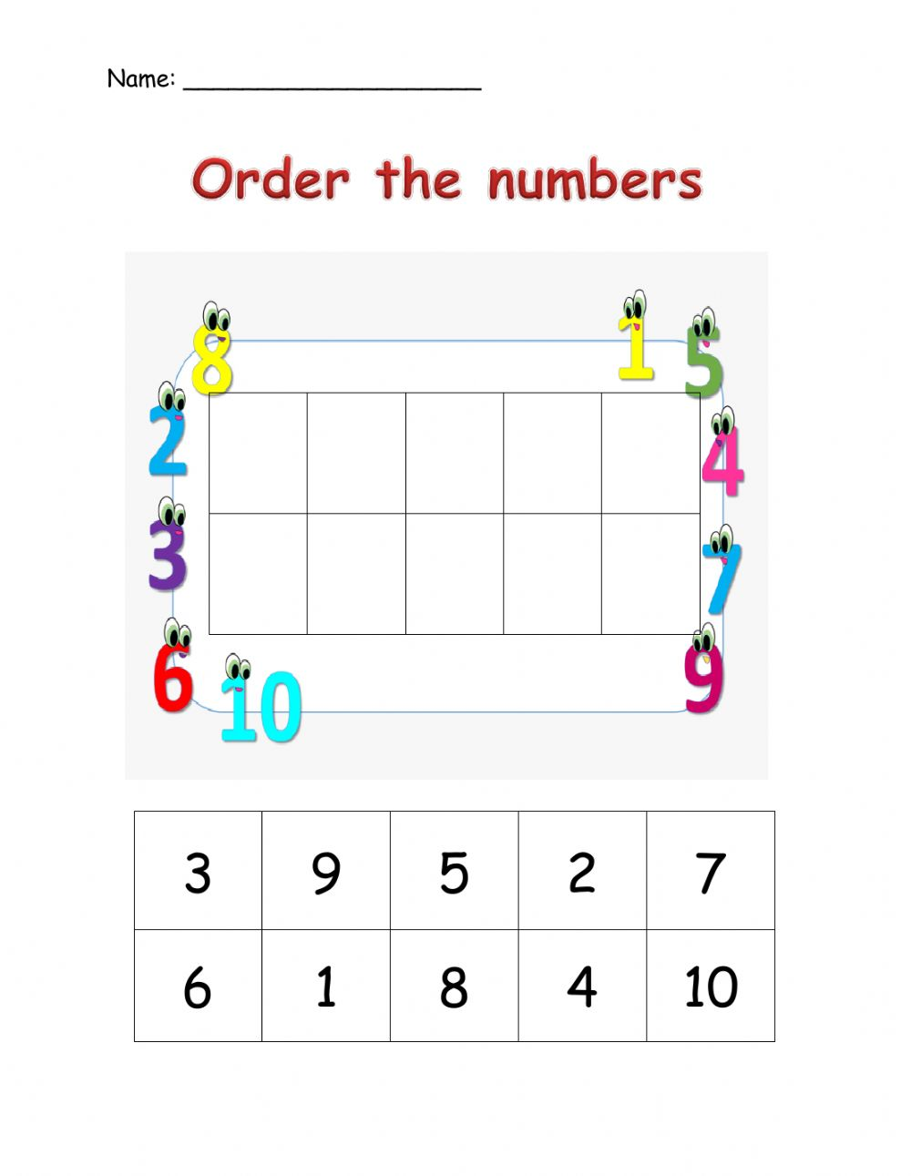

Greater than/less than
Compare the groups in each row an write the correct sign in the middle

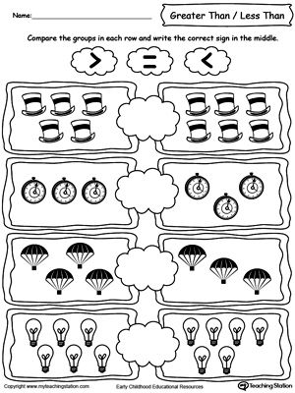

Group 3

Describe, compare and order numbers.
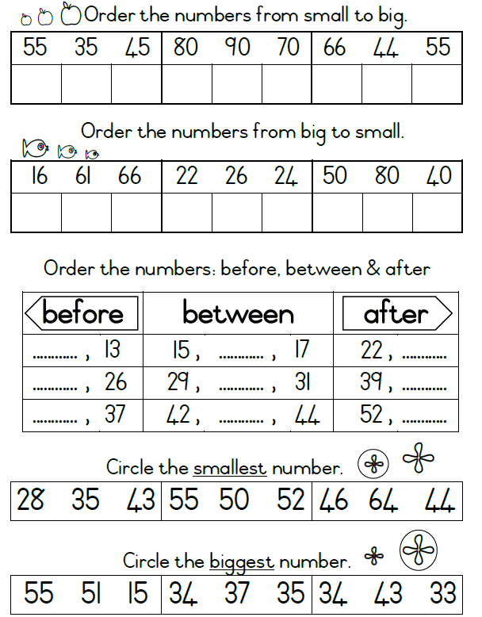

Describe, order and compare

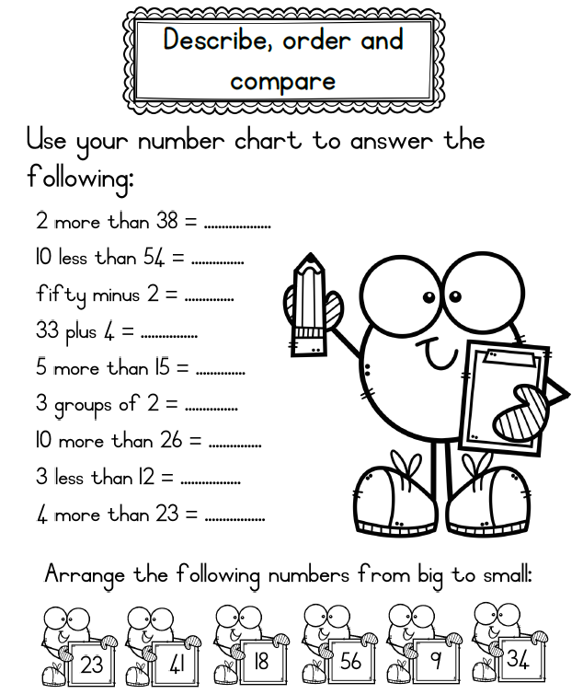

Write down the numbers in order from least to greatest.
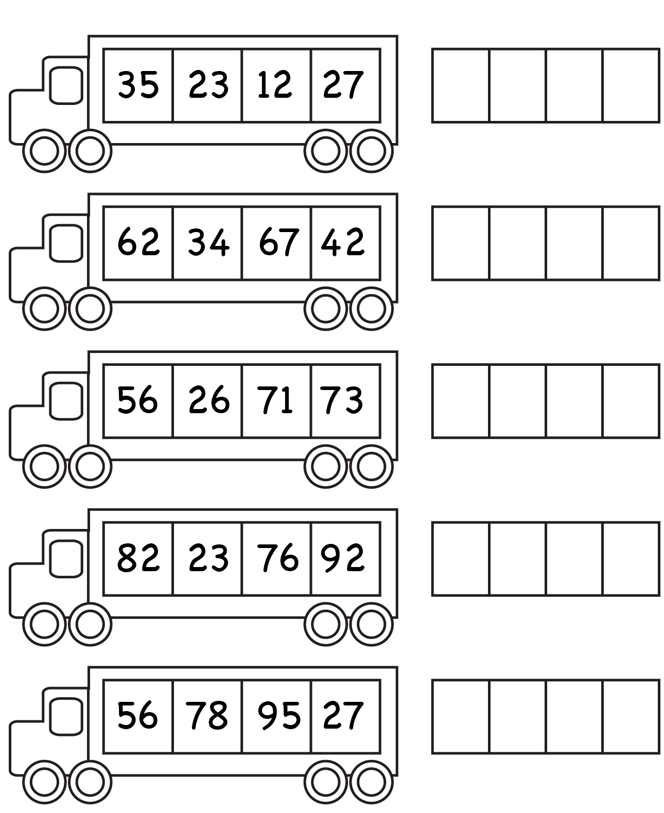
Week 4

Group 1

Recognise South African money
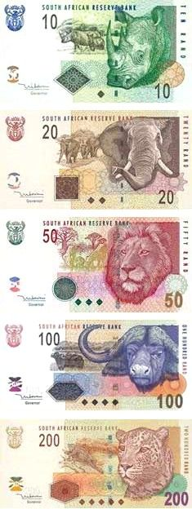

Recognise South African coins
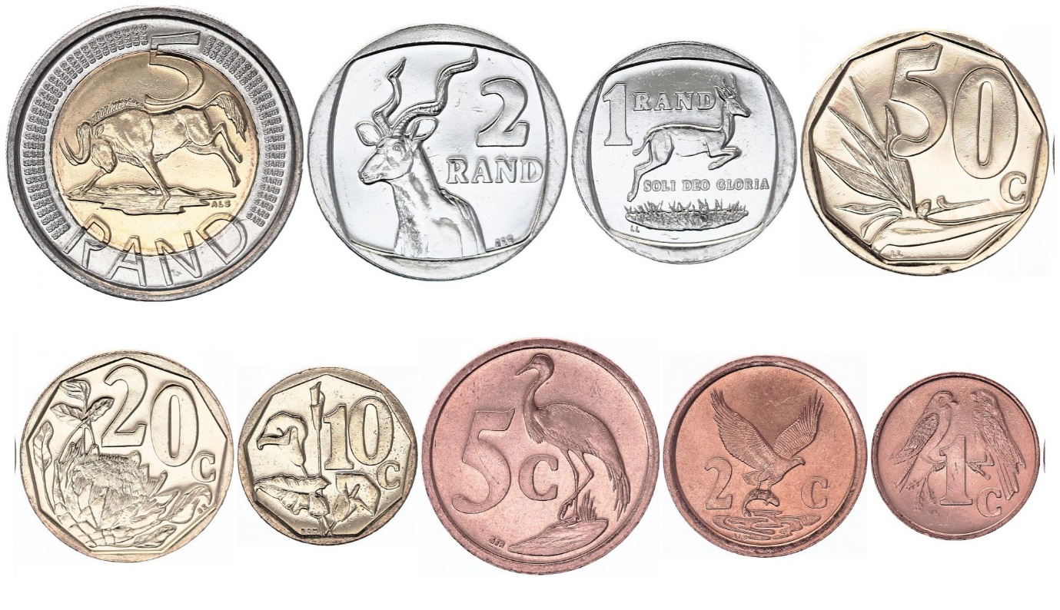

Identify coins and their names
Draw a line to match with its name

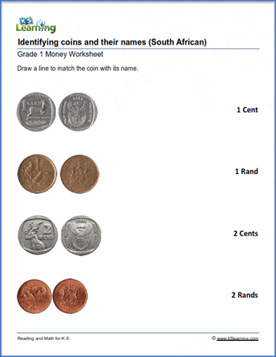

Group 2

South African money.
Add the coins together and write the answer in rands.
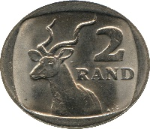 $+$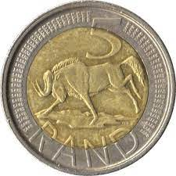 $+$ 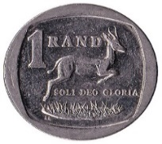$=$R
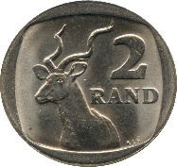 $+$ $+$ 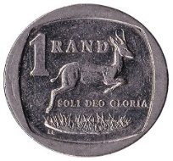 $+$ $=$R
$+$ $+$ 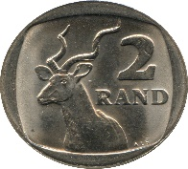 $+$ $=$R
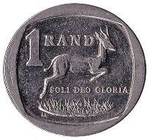 $+$ $+$ $+$ $=$R

Money
Answer the following questions and circle the correct amount of coins to the right-hand side to match the value of the coin on the left.
- How many R1 make R5?
_____________________________________
- How many R5 make R1o?
_____________________________________
- How many R2 make R8?
_____________________________________
- How many R1 make R10?

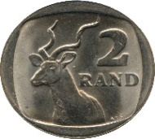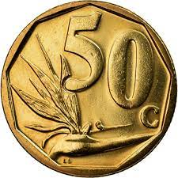

Add the following cents and write the total.
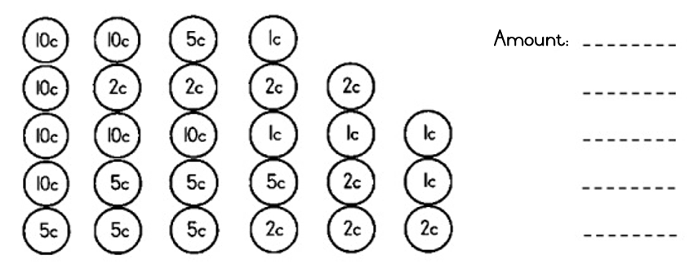

Group 3

Add up the coins.
Add the cents to make the next full Rand.

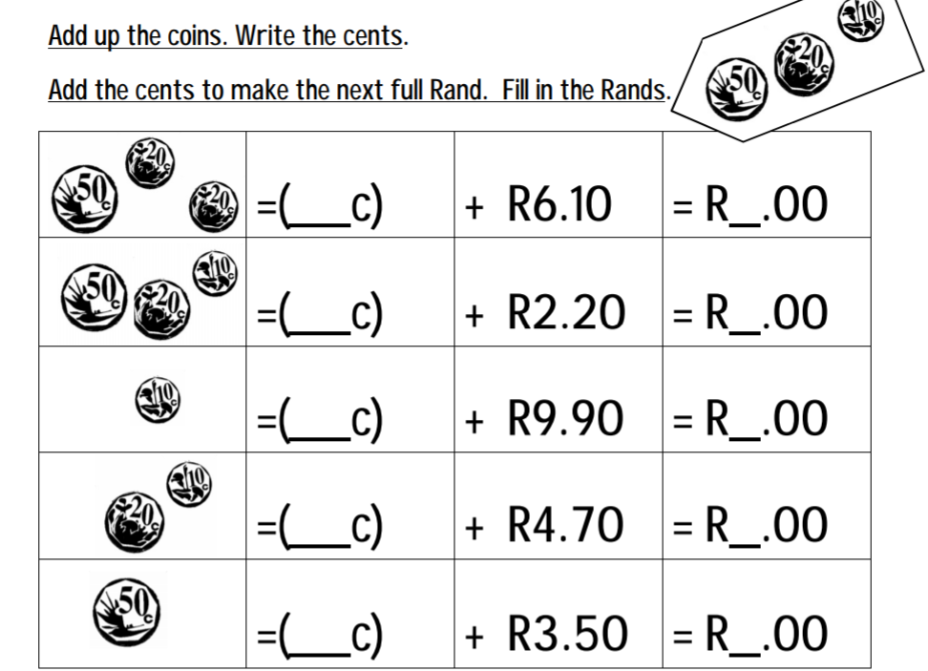

Add the coins together and write the answer in rands and cents
$+$ $+$$=$R
$+$ $+$ $+$$=$R
$+$ $+$ $+$$=$R
$+$ $+$ $+$ $=$R

Add the following amount of money and write the total
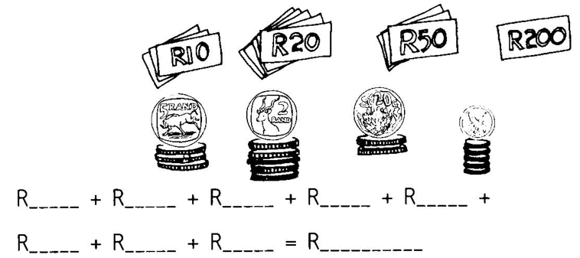

Week 5

Group 1

Addition
Find the sum for each addition problem. use the sum to find t5he correct colour at the bottom.

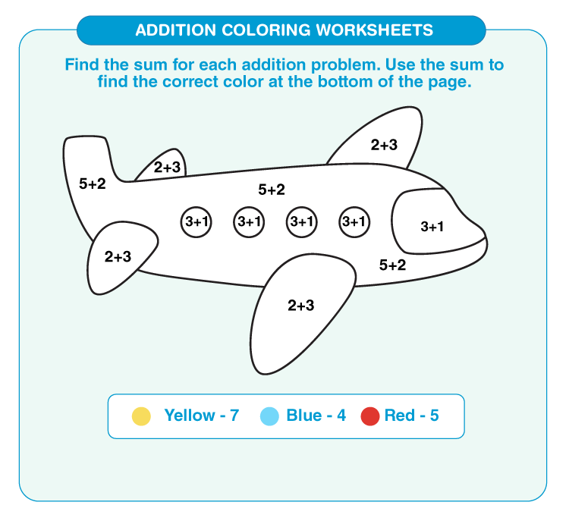

Subtraction
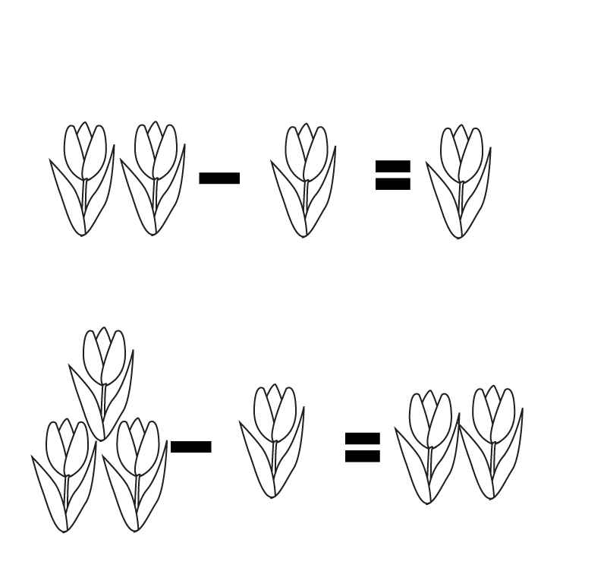

Addition
Find the sum for each addition problem. use the sum to find t5he correct colour at the bottom.
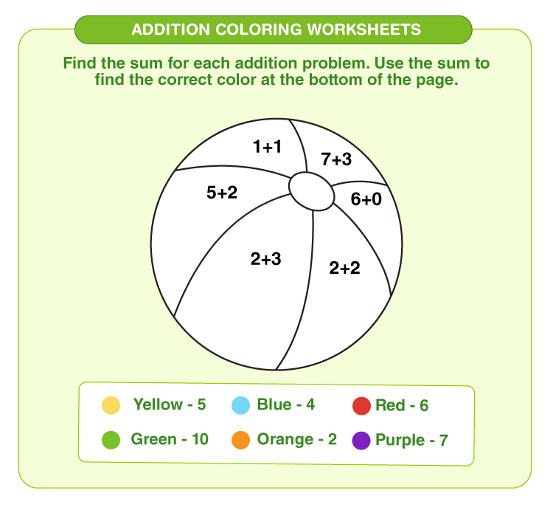

Group 2

Find the missing number and solve the equation below.

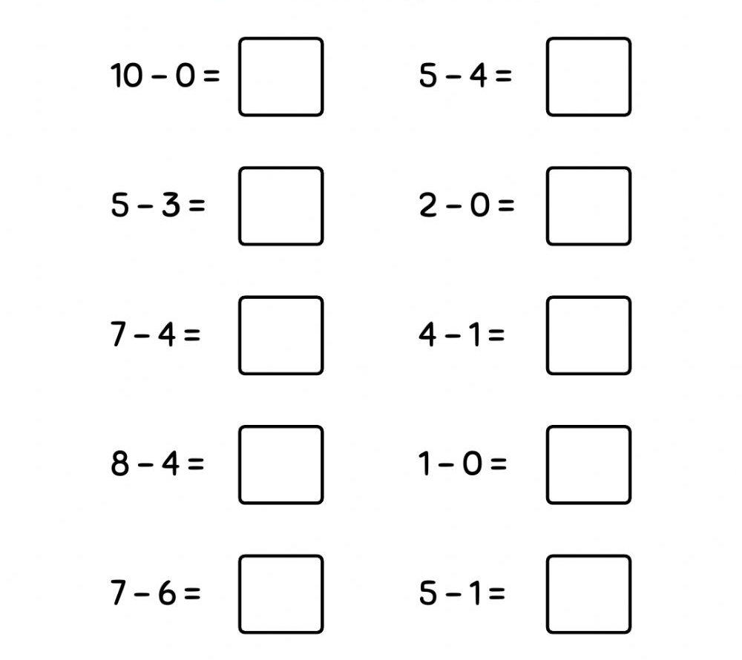

Addition to 20
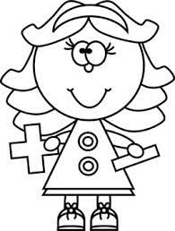

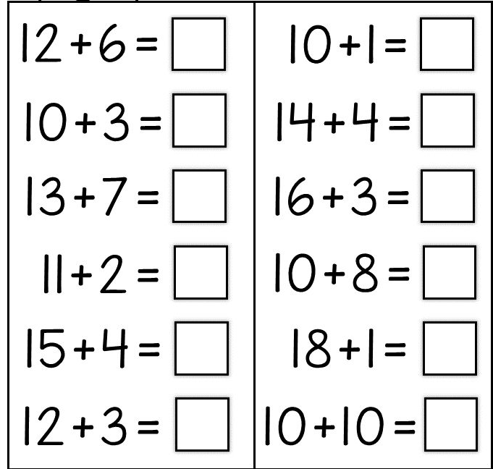
Addition to 10

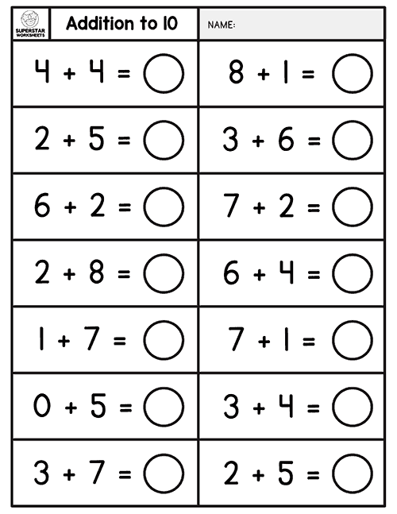
Group 3

subtraction

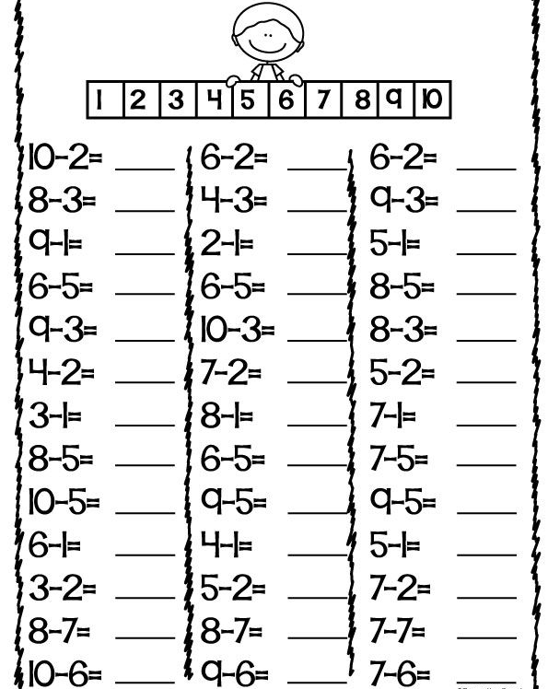
Simple addition and subtraction

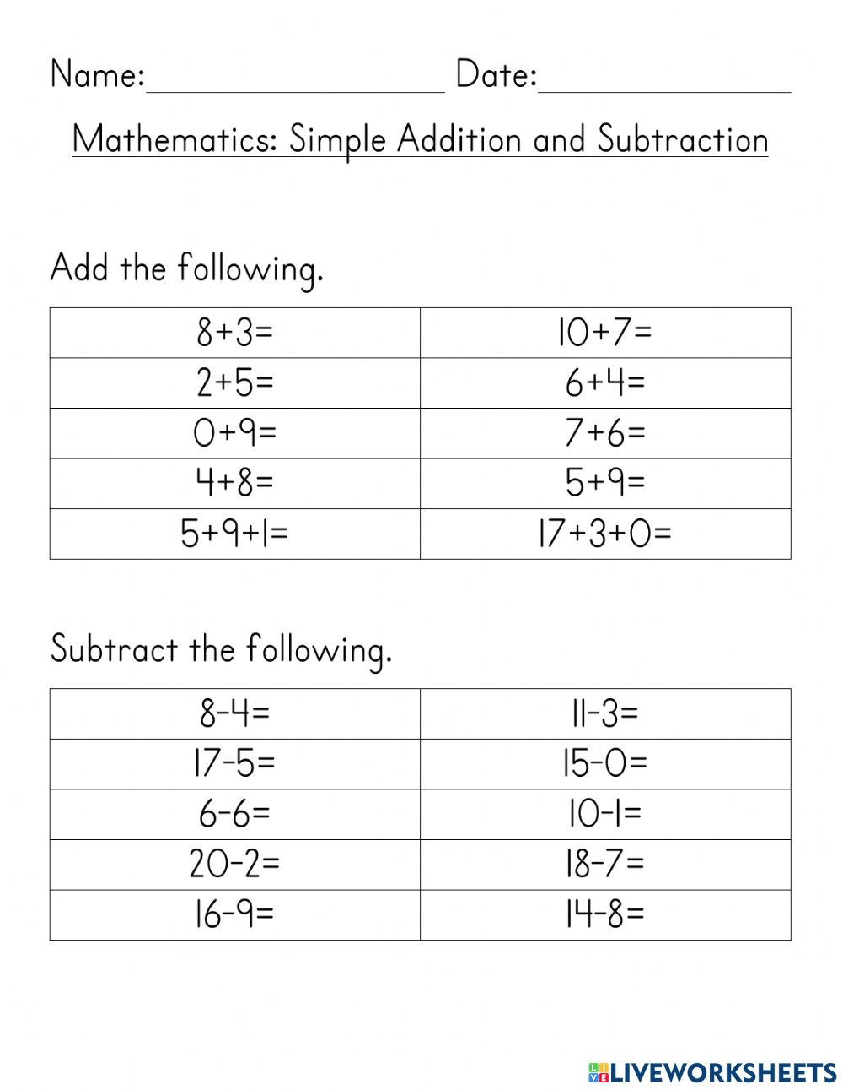

Week 7

Group 1

Where is the ball?
Circle the word that describes the balls position in the box.

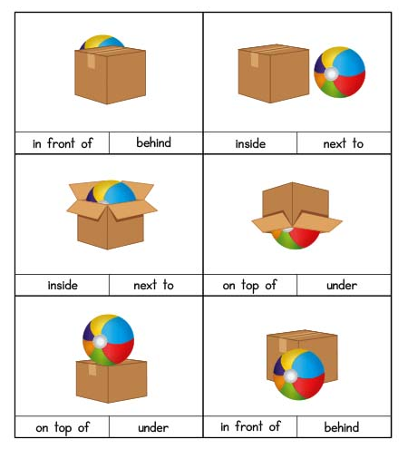

Where is the B ee?
Circle the word that describes the bee’s position.

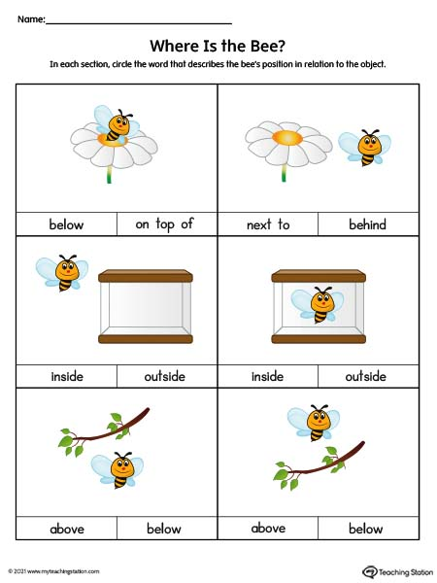

Position
Top, middle and bottom

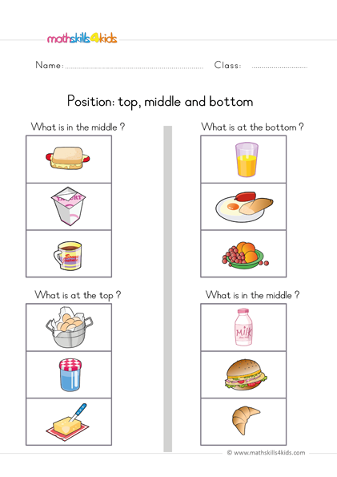

Group 2

Fill in the following positions
Between, next to, on, over, in, under.

